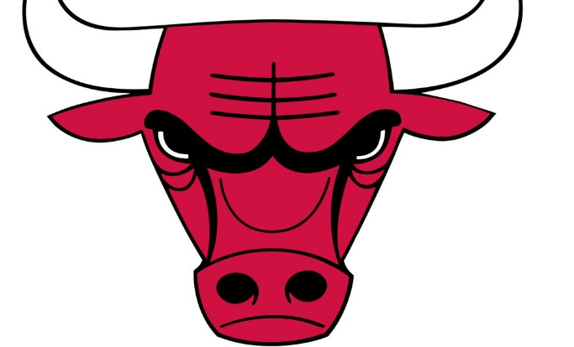
MICHEL JORDAN

1.What is your complet name?
- Michael Jeffrey Jordan
2.What is your favourite team?
- Charlotte Hornets
3.What is your company?
- A part of Nike and franquice of Charlotte Hornets
4.Where do you live?
- In North Carolina
5.Where do you start playing basket?
- In my Carlifornia neighborhood
6.Where do you start playing baseball?
- In chicago White Sox
7.When did you start playing in NBA?
- In 1984
8. When did you finish playing in NBA?
- In April 2003
9. When did you make the Looney Tunes film?
- Space Jam, in 1996
10.Who was your father?
- James M.Jordan was a coach of baseball
11. Who is your manager?
- Estee Portnoy
12. Who is the best basket player for you now?
- Larry Joe Bird the Boston Celtics
13. Why did you make the film?
- For fun
14. Why did you play baseball?
- for my father and try another sport
15. Why did you go back to basketball?
- because I love it and it was better to play than baseball
16. Which is your favourite animal?
- The dogs
17. which is your favourite food?
- The Hamburger
18. Which is your favourite city to live?
- Chicago
19.How old are your?
- 57 years old
20.How much money did it earn Space Jam?
- 230 millons of dolars
21. How were you the best player of history of basketball?
- With effort,work and passion
