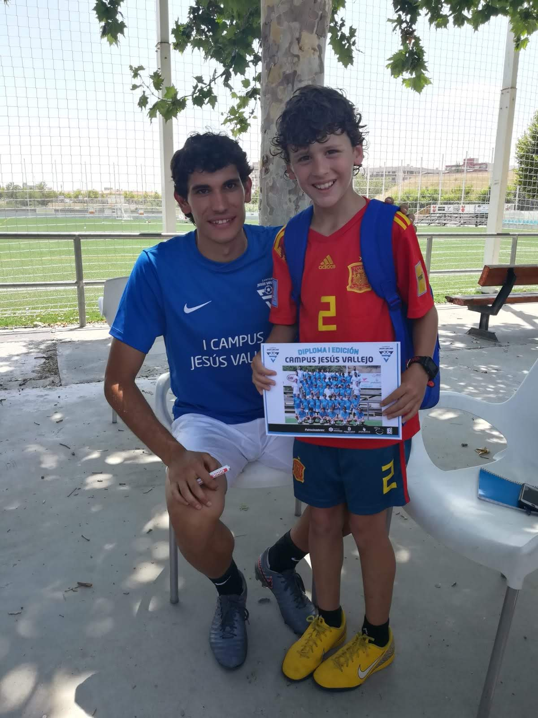
JESÚS VALLEJO interview.
- How are you?
  - I´m fine, thanks.
- Where are you playing now?
  - I´m playing in Granada
- How do you adapted to Granada?
  - Very good, Granada is a beautiful city and very calm.
- Who is in Granada with you?
  - I live with my girlfriend. She help me a lot of in the quarantine.
- How was your quarantine period?
  - Well, I have been training in the garden, watching movies and reading books.
- Where were you born?
  - I born in Zaragoza, but I grew up in Loscos, a little Aragón Village.
- What is your favorite team?
  - My favorite team is the Real Zaragoza.
- When did you debut with Real Zaragoza?
  - I debuted at 17 years old. We played in Huelva versus the Recreativo.
- How did it feel to debut with your favorite team?
  - It was a experience that never feel two time on my live.
- You don´t scored many goals. What do you remember about your first goal?
  - Jaja, it´s true. My first goal was vs Tenerife in the Heliodoro Rodriguez stadium.
- Why did you leave the Real Zaragoza?
  - Because the Real Zaragoza made a deal with Real Madrid.
- You went to play in Germany. Where did you go?
  - I played in the Eintracht Frankfurt. It was difficult at first to learn German in such a short time, but I learned a lot there.
- Who do you remember of Germany?
  - I remember to greats players of Bundesliga which Lewandowski, Perisic, Neuer, Marco Reus, Hummels ,…
- Which one trains more?, Ronaldo or Adama Traoré
  - I saw both trains very hard, buy I think that Adama Traoré is a beast.
- Why have you played this year in the premier?
  - The Madrid sent me on Wolverhamptom.
- Which is been your best experience, Germany, England or winning the U21 Euro?
  - My best experience is to win the U21 Euro.
- Who do you remember from that selection?
  - I remember a Ceballos, Fabián, Marc Roca, we are a big family.
- In summer you usually make football´s campus, when do you do the next campus?
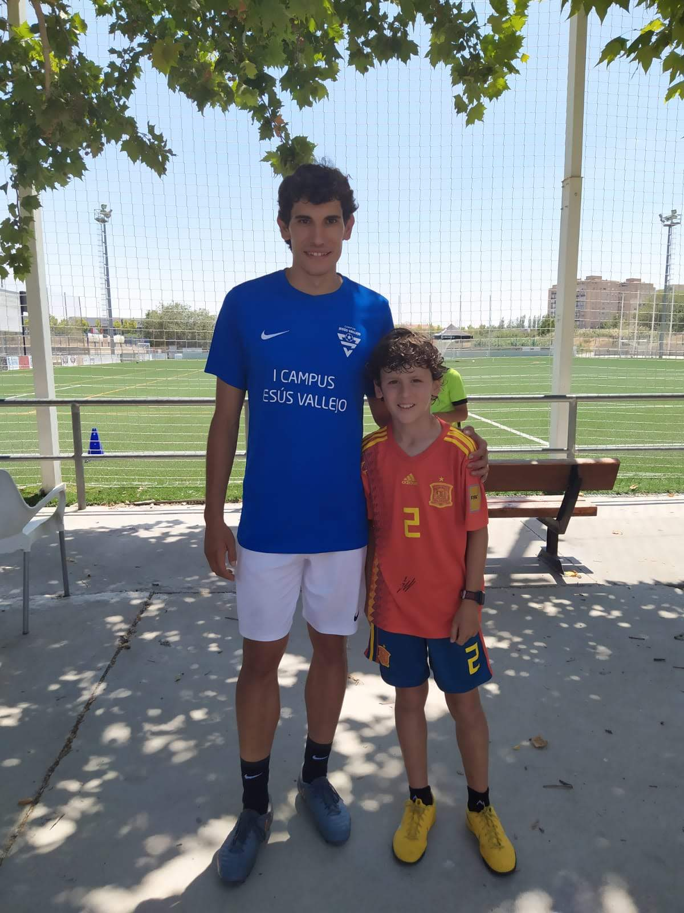
  - This year is not possible make the campus football, I´m sad for my children.
- Where did you go on vacation last time?
  - I went to Thailand, whit my friends.
- What teams do you think will go up this year?
  - Is very difficult but I think go up Huesca and Zaragoza
- When do you come back to Real Zaragoza?
  - I hope come back before to 26 years old
- Why do you play football?
  - Because when I´m at kid I like so much play football in my village with my friends.
- The last question, which is your favorite color?
  - My favorite color is the blue
- Bye, I see you soon
  - Bye, thank you for the interview

