INTERVIEW: CRISTIANO RONALDO
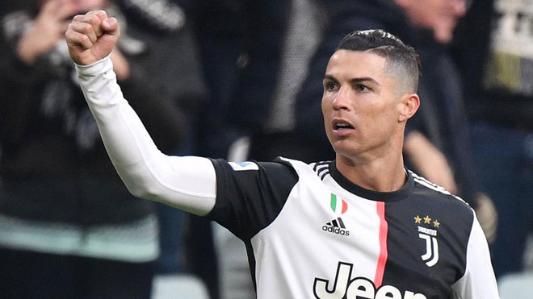
I am Alejandro and today we have the star of football Cristiano!!

Alex- When did you start to play football?

CR7- I started in 1992

Alex- What is the name of your first team?

CR7- My first team was Sporting Lisbon

Alex- Who was your idol when you are a child?

CR7- He was Figo

Alex- Where were you born?

CR7- I were born in Funchal

Alex- Which is your favorite coach?

CR7- He is Mourinho

Alex- Why did you start to play Sporting Lisbon?

CR7- Because it was the team of my country.

Alex- How are you so good in football?

CR7- Because I was born so

Alex- What is the name of your mother?

CR7- The name of my mother is Maria Dolores Do Santos

Alex- How many sisters do yo have?

CR7- I have two sisters

Alex- Which was your favorite team when you was a child?

CR7- It was Benfica

Alex- What is your favorite food?

CR7- It is bacalao

Alex- When did you come to Spain?

CR7- I came in 2009

Alex- Who was your best friend in Real Madrid?

CR7-He was Marcelo

Alex- Why did you choose the Real Madrid?

CR7- Because I loved it

Alex: How many sons do you have?

CR7: I have four sons.

Alex:Where do you live?

CR7: I live in Madrid

Alex: Which is your favorite color?

CR7: It is red

Alex:What do you do in the summer?

CR7: I go to the beachs of Portugal

Alex: Why do you leave of Real Madrid?

CR7: Because I wanted more money

Alex: Who is your singer favorite?

CR7: He is Nicky Jam

Alex: When do you come to Real Madrid again?

CR7: I want to come early becase I miss very much....

